Lab Exercise 3
Push Notification Service
(Version 2.0)

Author(s):

Mangalaganesh Balasubramanian, GBS BPM & I , Australia
Kaustubh Roy Chowdhury, GBS India
Shri Santhana, GBS Singapore
Manendra Rawat, GBS India
Shahir A. Daya, GBS Cloud CoC
William A Brown, GBS Cloud CoC
Table of Contents

1 Pre-requisites to participate in this lab 3
2 Learning objectives 3
3 Push Notification Service 3
3.1 Create a Mobile Cloud application in Bluemix 4
3.2 Configure Mobile Application to use GCM 7
3.3 Create an Android Application to receive push notifications 15
3.4 Run the Android Application and view notifications 23
References 28

Pre-requisites to participate in this lab
What do you need to participate in this lab? You need an IBM Bluemix account
(https://ng.bluemix.net), the Android Development Toolkit (eclipse) with Google Play Services installed, and a modern browser like Chrome, Firefox, IE10+ or Safari.

Learning objectives
This lab shows how to add Push notifications to a mobile application using the Push notifications service in Bluemix.
When the lab is completed, your application will be running on the web and will be able to be administered (stop, start, monitor) via the Bluemix user interface.

Push Notification Service
The following figure shows at a high level the various components involved in the push notification process.
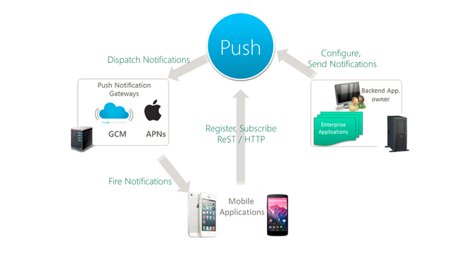

Create a Mobile Cloud application in Bluemix
In this section you will create a Mobile Cloud application in Bluemix that will serve as the mobile back-end for the Android app that you will be creating. If you have done Lab Exercise 2, this section is exactly the same as in Lab Exercise 2. You can actually use the Push notifications service in the Mobile Cloud application you created in Lab Exercise 2 if you prefer.
- Login to Bluemix and navigate to your dashboard.
- Click on CREATE AN APP
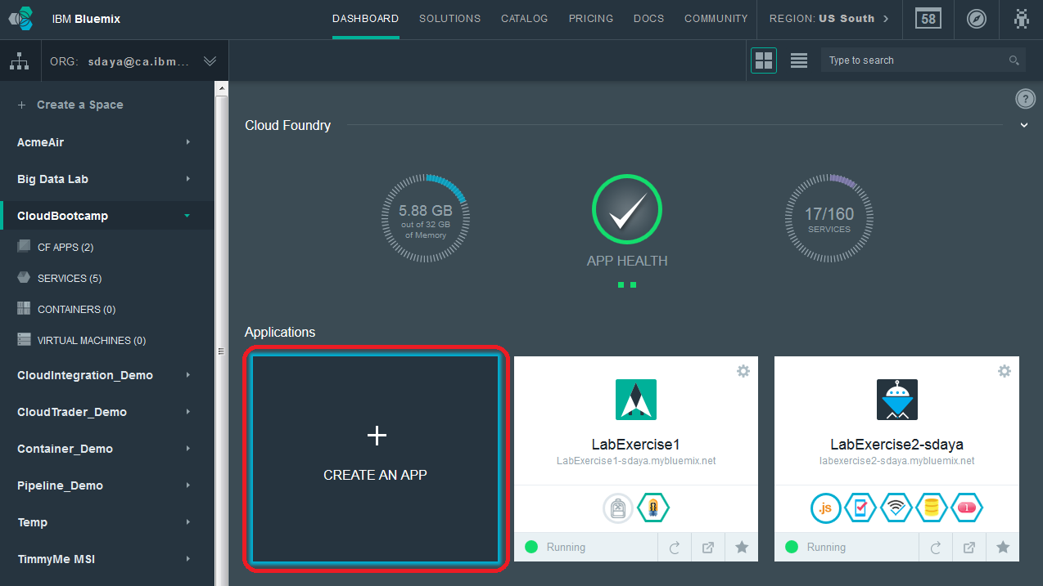
- Click on MOBILE for the kind of app we are creating
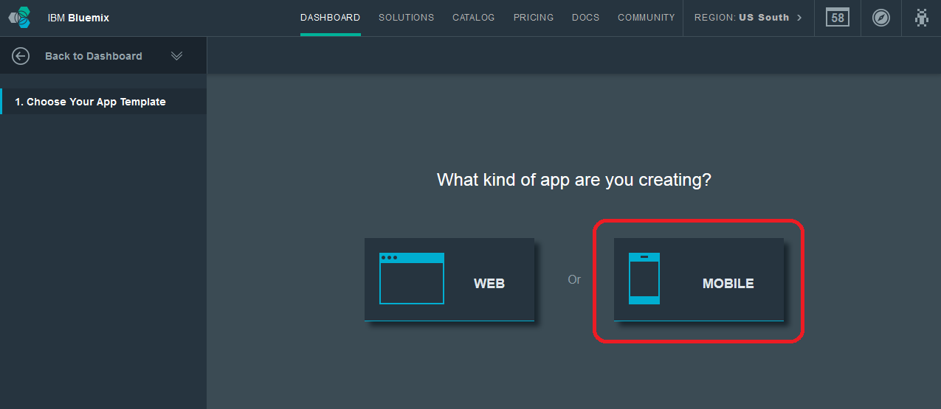
- Click on Mobile (iOS, Android, Hybrid) as the platform
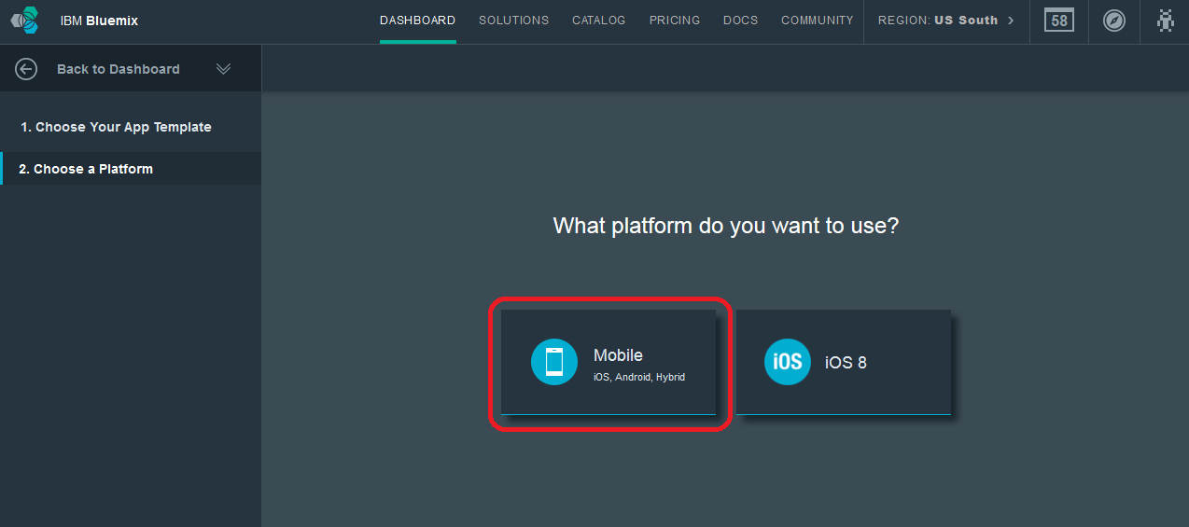
- Click the CONTINUE button.
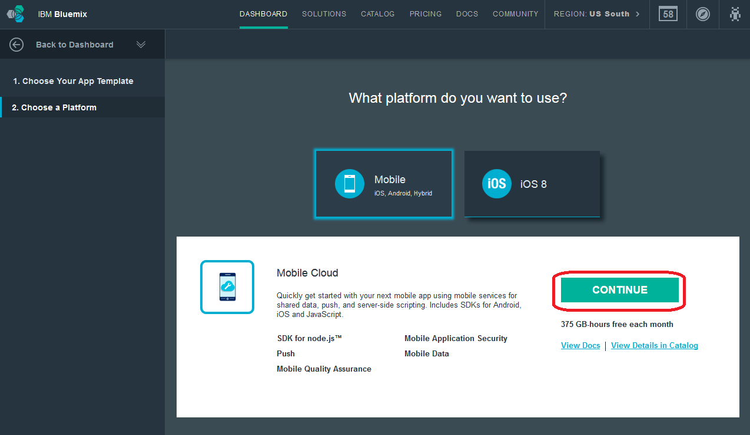
- Give the application a name and click the FINISH button
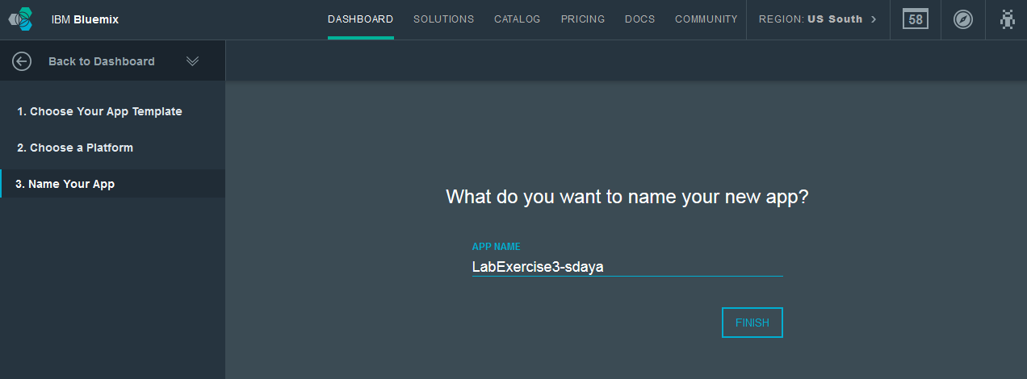
- You will now be presented with a page with details on how to enable your web application for mobile. Click the CONTINUE button after you have read and explored this page.
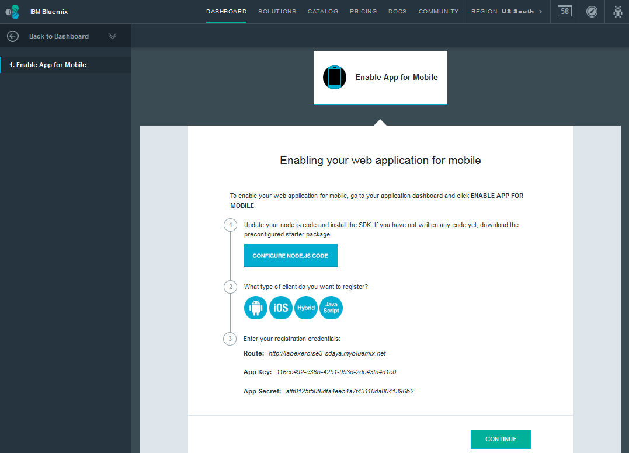
- You will now see the application overview page for your newly created application.
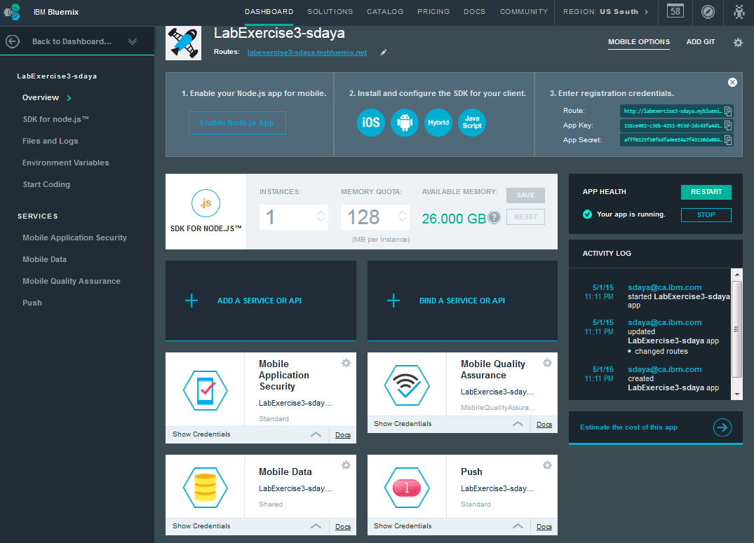
- Click the Back to Dashboard link to go back to the DASHBOARD
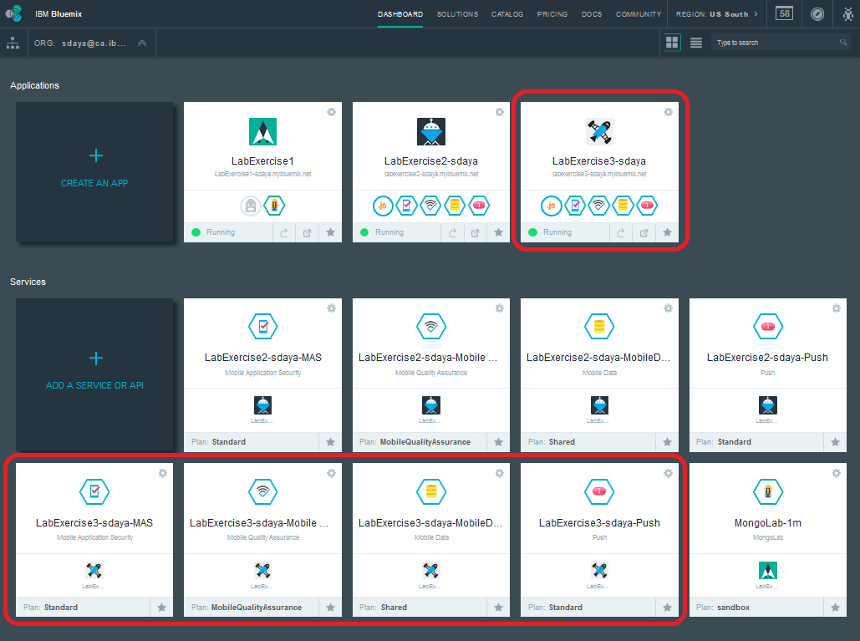

Configure Mobile Application to use GCM
In this section you will setup a Google Cloud Messaging (GCM) implementation and configure the mobile application created earlier to use GCM for the push services.
- Create a Google Project to use GCM APIs
- Navigate to Google Developers Console (https://cloud.google.com/console)
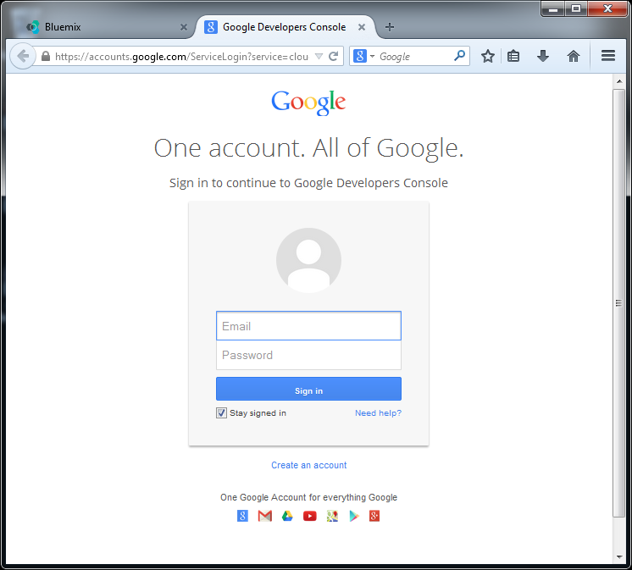
- Click on Create Project
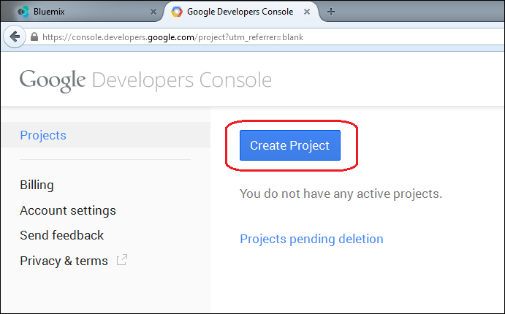
- Choose a name for the project and project ID. A generated value is created for your project ID. You are free to choose a different ID if you like. The figure below shows a custom value that we have chosen. Click Create to create the project.
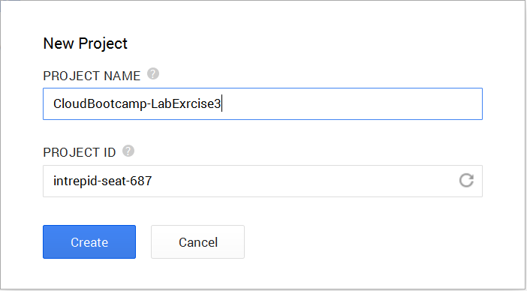
- The Google project is created successfully and you should see the project dashboard.
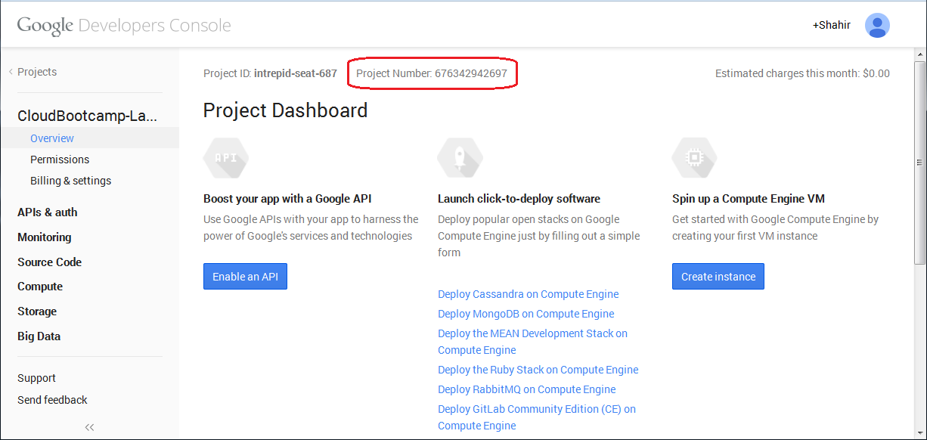
- Copy the project number as this is used as the GCM Sender ID
- Enable GCM Service
  - Choose the APIs under APIs & Auth in the navigation bar
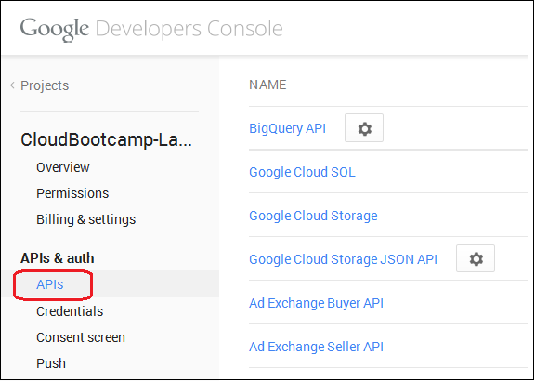
  - Locate Google Cloud Messaging for Android and click on Off to turn it On.
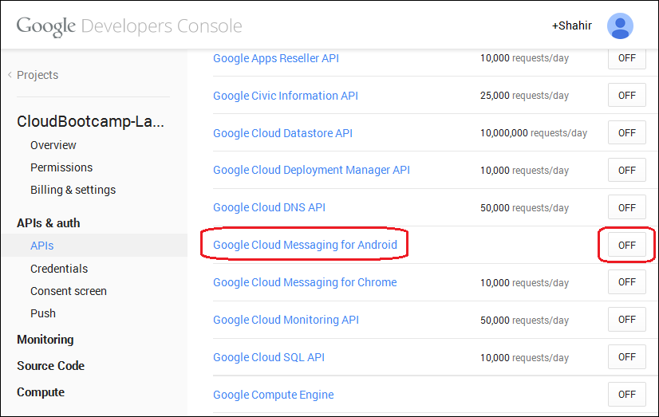
  - Read and accept any T &Cs that are presented.
  - Google Cloud Messaging for Android will be turned on and it should be available at the top of the list now.
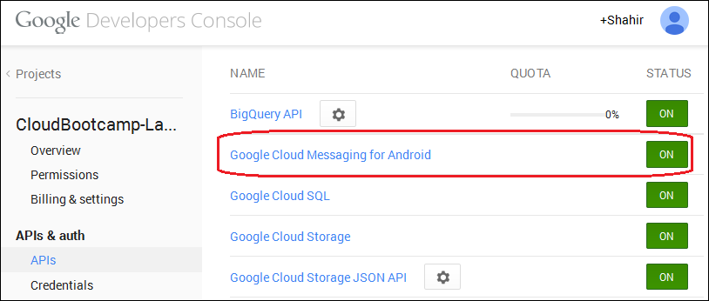
- Obtain an API Key
- Click on Credentials in the Navigation bar
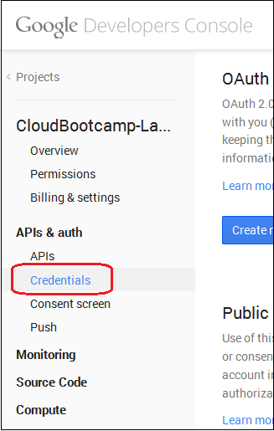
- Create new key by clicking on "Create new Key"
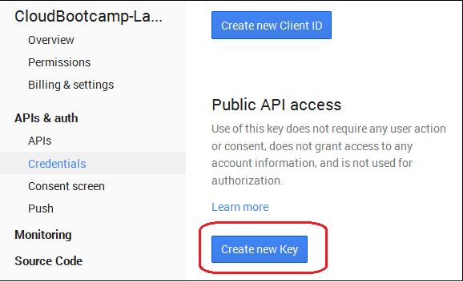
- Choose Server Key
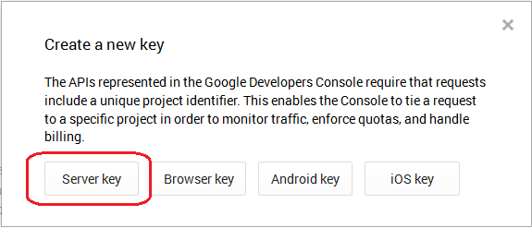
- Enter 0.0.0.0/0 as the IP Address to accept requests from and click Create
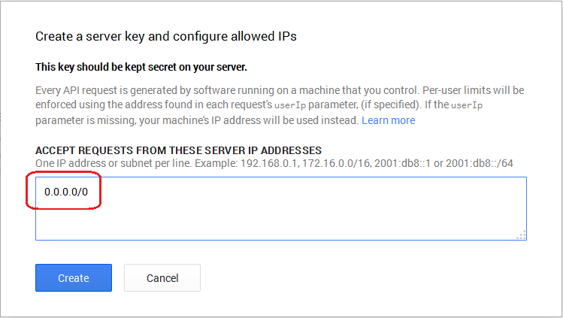
- Copy the API Key that is generated along with the project number.
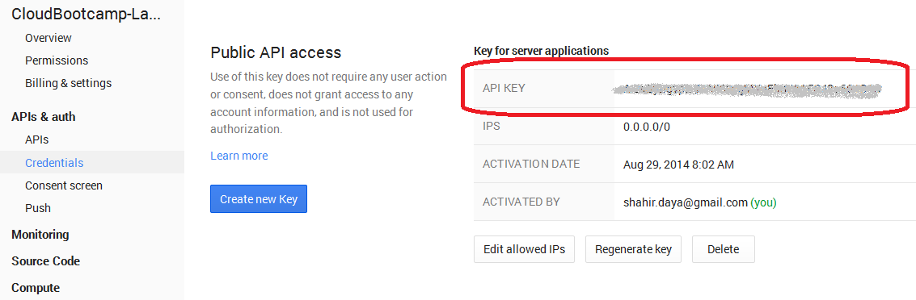
- Specify the generated API Key and Project number in the mobile application that we created earlier.
- Navigate to the Bluemix dashboard and click on the LabExercise3 application to view the overview page of our application
- Click on Push in the navigation area to configure the push service
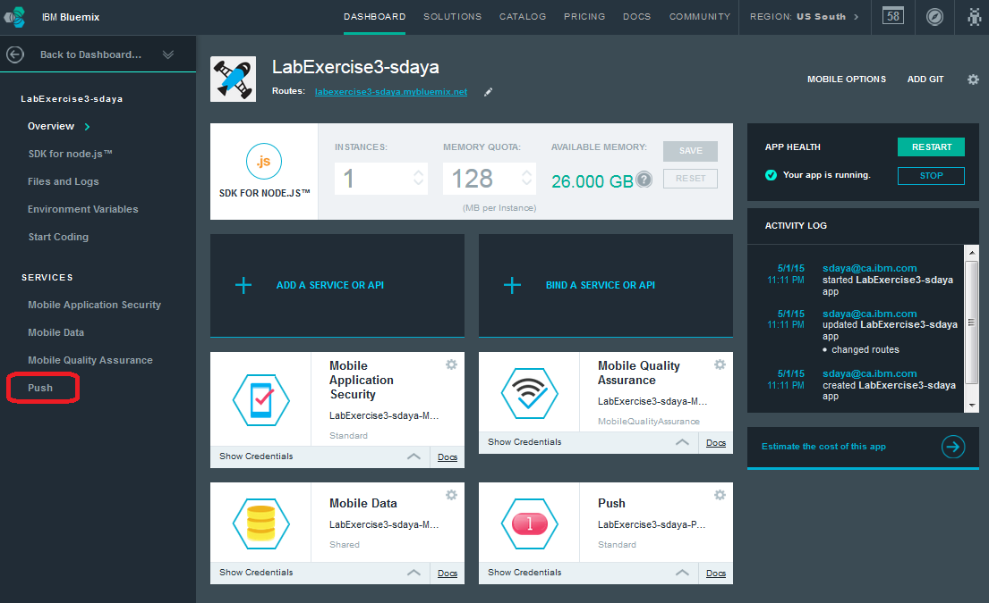
- Click on EDIT under the Google Cloud Messaging
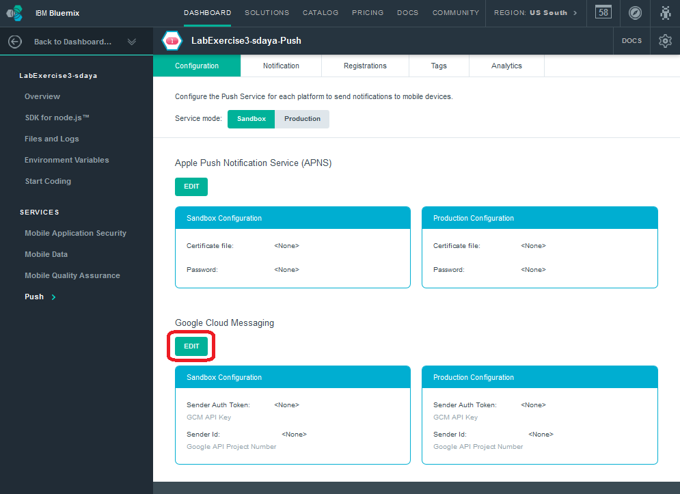
- Specify the GCM API Key and Project number and click "Save".
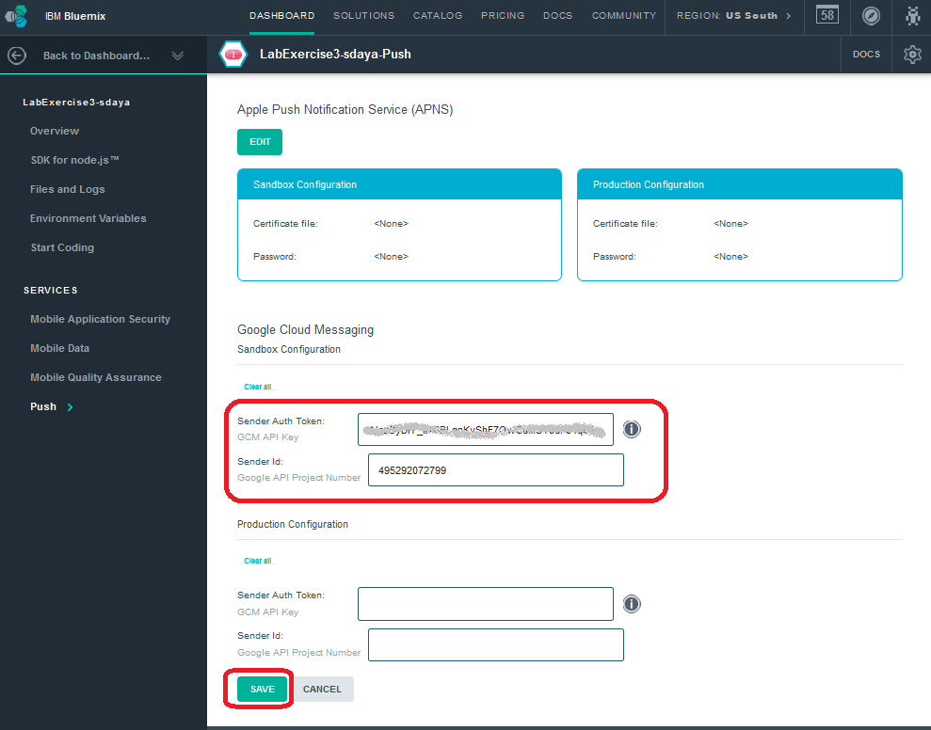
- The GCM Configuration is saved successfully.
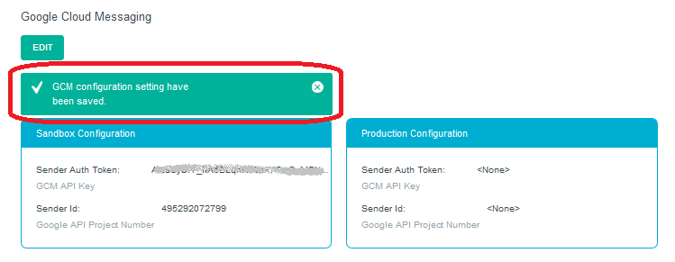
The push service is now configured to use GCM and can send notifications to android applications.

Create an Android Application to receive push notifications
In this section you will import an android application in Eclipse and use the emulator to receive push notifications from the mobile cloud app.
- Open Eclipse bundled with the Android SDK
- Import the Push Notification Android Application
- Click File → Import...
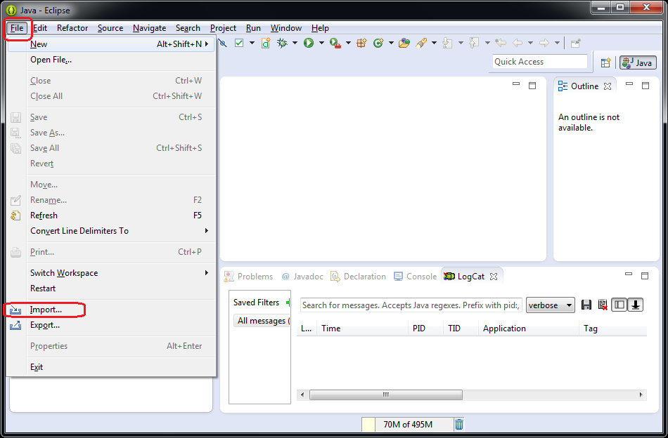
- Choose "Existing Android Code Into workspace"
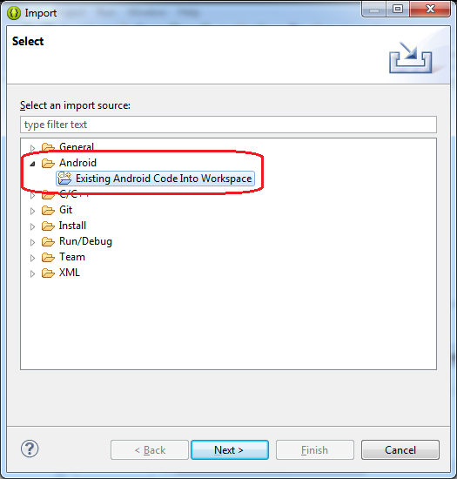
- Extract the “LabExercise3 - required files - v1.0 08292014.zip” ZIP file to a temporary folder.
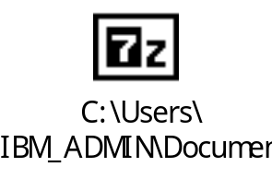
- Specify the “LabExercise3" folder that is in the extracted ZIP as the Root Directory. Also, check the “copy projects into workspace” checkbox.
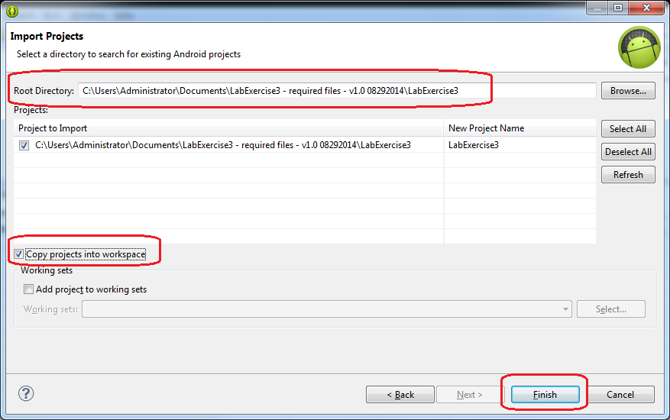
- Click "Finish" to complete the import.
- The Project could have a number of errors and we will resolve these errors before proceeding further.
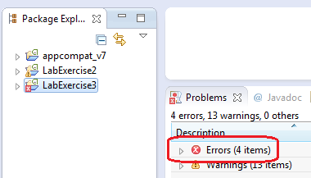
- Let's eliminate all the errors and ensure that eclipse is happy with the imported project.
- The build path from the imported project might be incorrect. This is typically reflected by the message - "unable to get system library for the project". Resolve any errors you have in the build path.
- The Java build path should look like the figure below
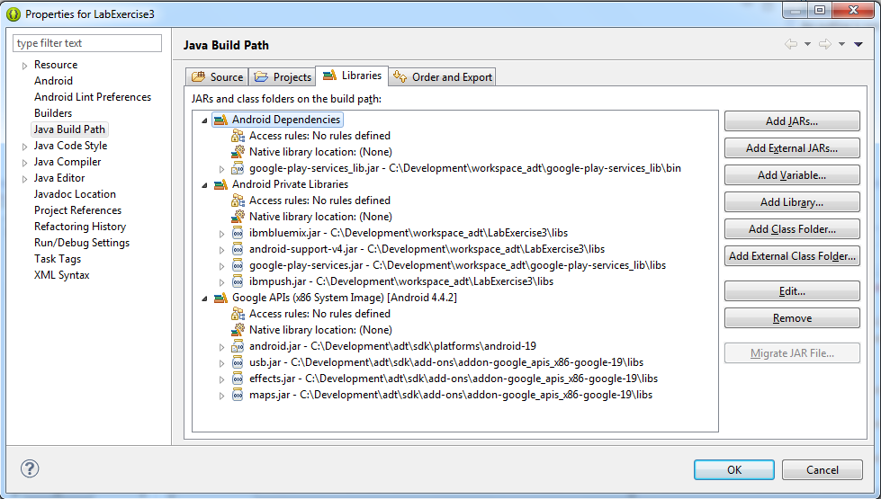
- Click "OK" and clean the workspace.
- Import the google-play-service-lib to the project.
  - Select the LabExercise3 project, right-click on it, and from the context menu choose Import...
  - Select "Existing Android Code Into Workspace"
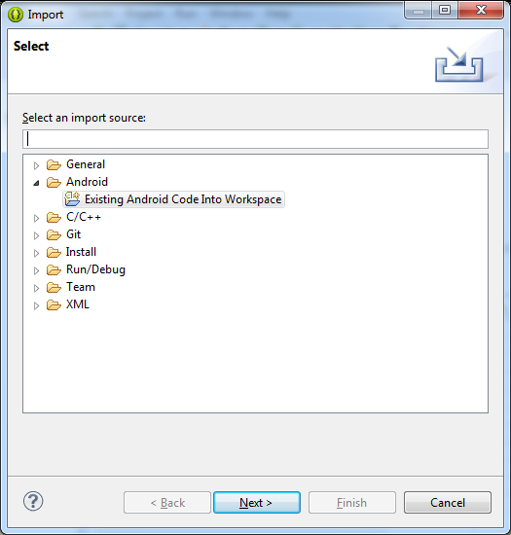
  - Click Next
  - Specify the root directory as "C:\Development\adt\sdk\extras\google\google_play_services\libproject\google-play-services_lib". Change this to the appropriate directory where the ADT bundle is installed on your machine.
  - Select copy projects into workspace
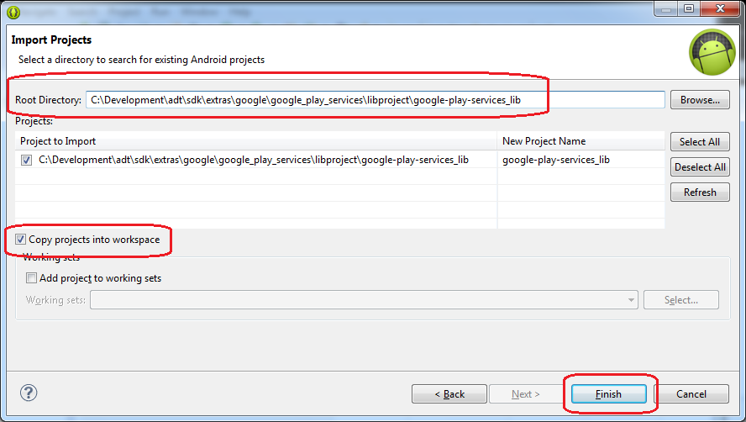
  - Click Finish to complete the import.
  - A new project - "google-play-services_lib" is created in the workspace
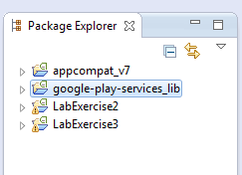
  - Let's check the Android settings and ensure that we have the correct values specified here.
  - From the project's context menu choose properties and click on Android
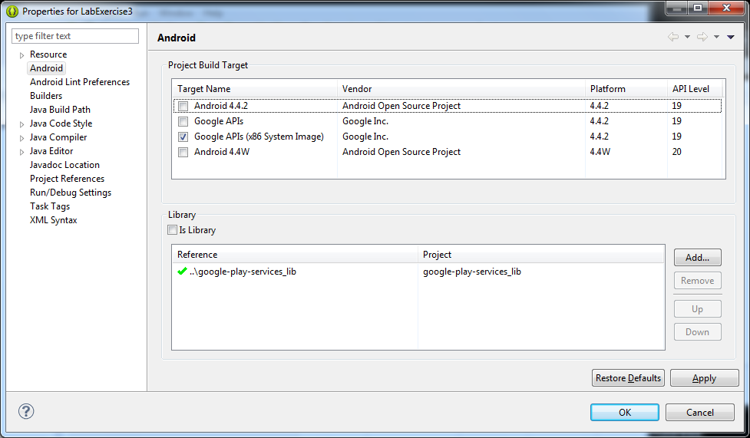
  - Ensure that a green tick is present next to google-play-services_lib in the Library section.
  - Make sure Google APIs (x86 System Image) is selected as the Project Build Target.
  - Clean the workspace and rebuild all the projects
  - There shouldn't be any errors now.
Note: In some cases, we observed that errors persist and restarting eclipse fixes the errors.
- Change the App ID, App Secret, and Route in the “PushActivity.java” file. Find the following line and replace the 3 placeholders with the correct values from your LabExercise3 Mobile Cloud application in Bluemix.
pd.setMessage("Getting Rich Notification");

IBMBluemix.initialize(this, "<APP_ID>", "<APP_SECRET>", "<APP_ROUTE>");

push = IBMPush.initializeService();
push.register("DemoDevice", "DemoUser");
Replace <APP_ID>, <APP_SECRET>, and <APP_ROUTE> with the values shown.
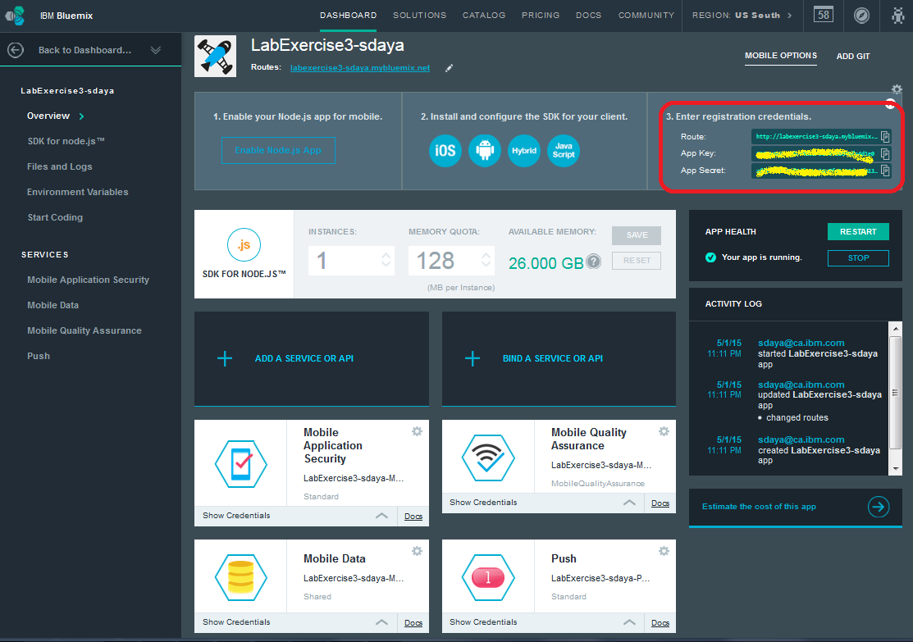
Also replace “DemoDevice” and “DemoUser” with values to identify you and your device (i.e. the emulator)
- Let's eliminate all the errors and ensure that eclipse is happy with the imported project.

Run the Android Application and view notifications
In this section you will run the application and using the emulator receive notifications that are sent from the mobile cloud app.
- Select the LabExercise3 project and select Run As --> Android Application
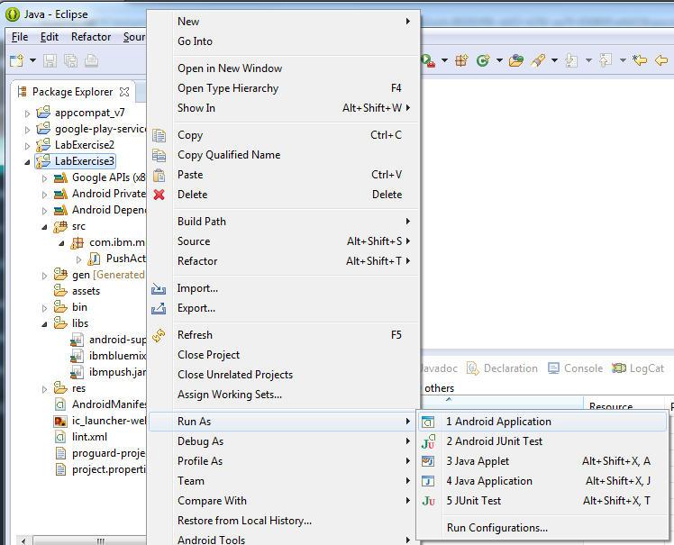
- If an Auto Monitor Logcat window pop up opens up, choose the priority as "verbose" to ensure that we get to see what is happening under the hood in the logcat view.
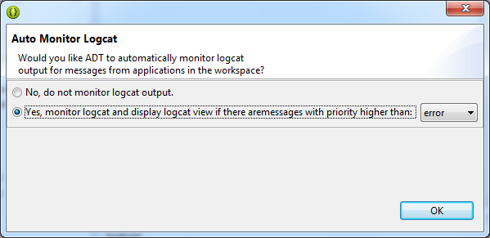
- The emulator should open up and the push service quick start should state that the device is registered with the push service
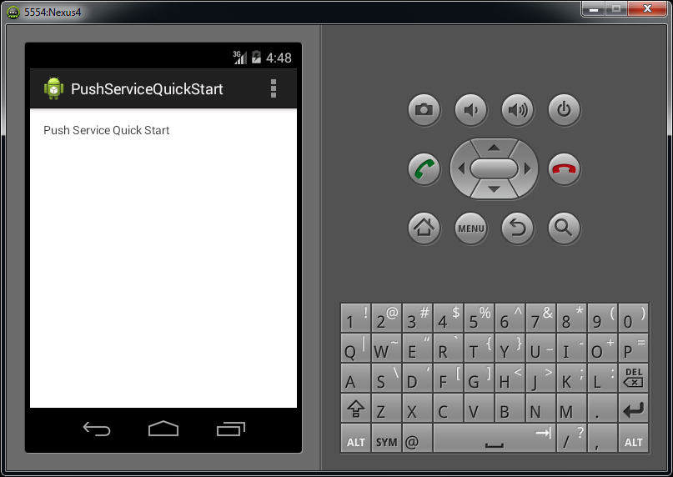

- Switch to the Bluemix dashboard and select Push in the navigation bar.
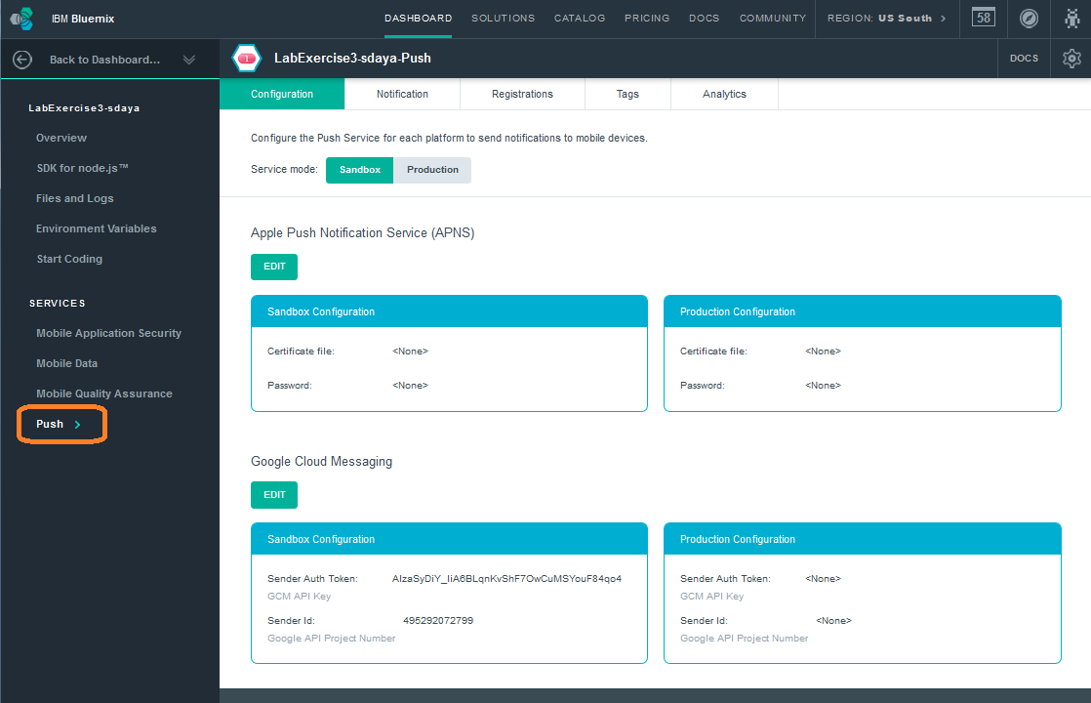
- Choose the Notification tab and enter a text message.
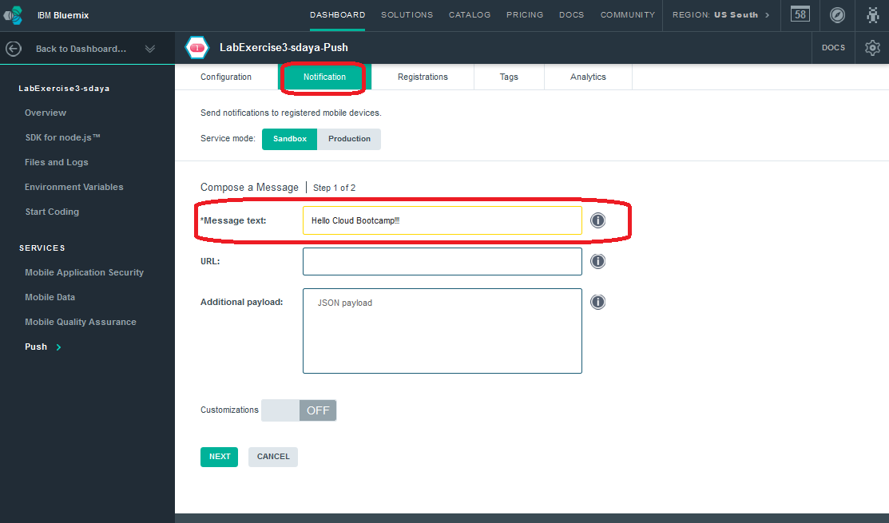
- Click NEXT
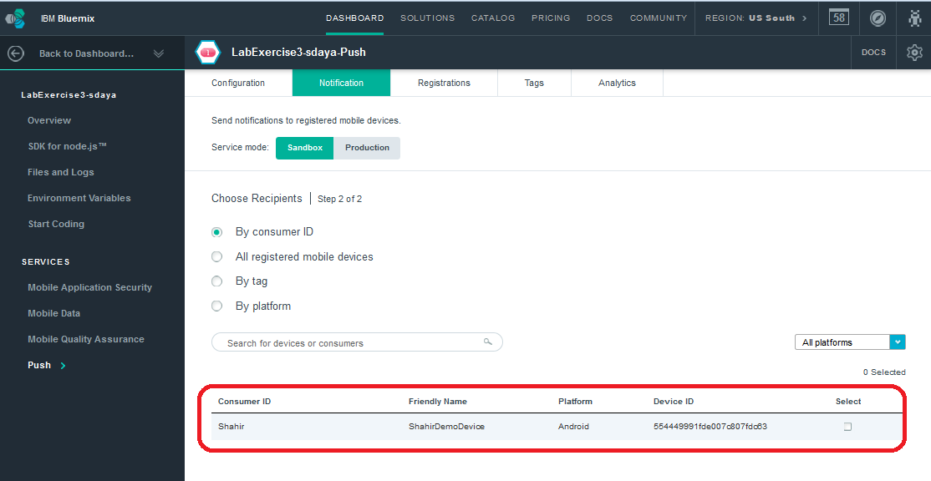
You should see your emulator show up as a consumer that is registered.
- Choose "All registered mobile devices" and click Send
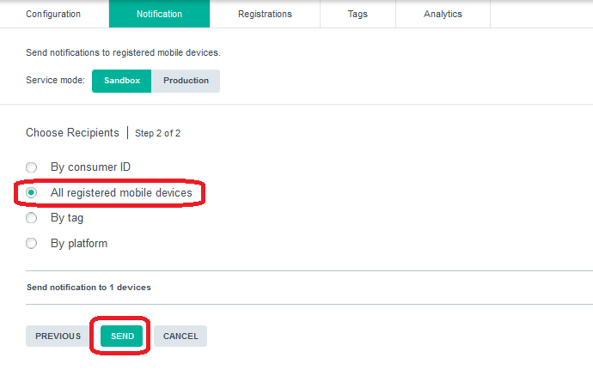
- The notification should be sent successfully. There is one registered device (our emulator) to which the notification was sent to.
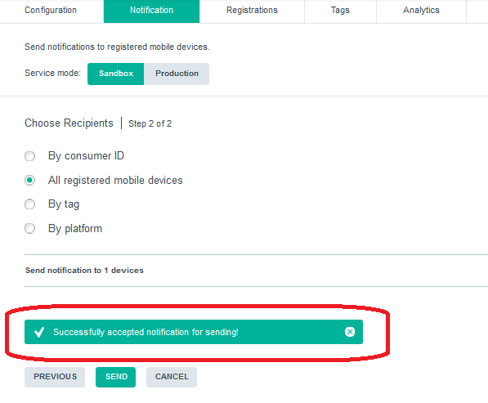
- The message should appear in your emulator.
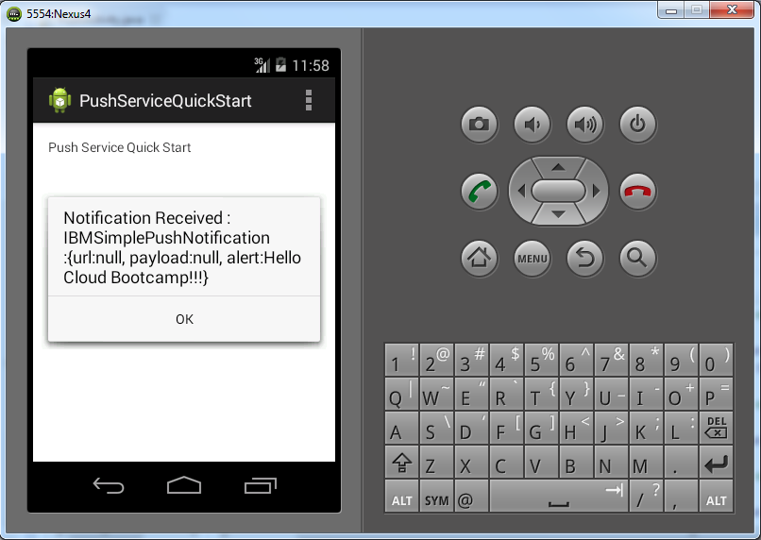
In this exercise you created a push notification application on Bluemix .You imported an android app and ran it on an emulator. From the bluemix application you created a notification and received it in the emulator.

References
- Building a mobile application, (2014). IBM Bluemix Docs. [online] Available at: https://www.ng.bluemix.net/docs/#starters/BuildingMobile.html [Accessed 28 Aug. 2014].
- Installing the Android SDK, (2014). Installing the Android SDK | Android Developers. [online] Developer.android.com. Available at: https://developer.android.com/sdk/installing/index.html?pkg=adt [Accessed 28 Aug. 2014].
- Setting Up Google Play Services, (2014). Setting Up Google Play Services | Android Developers. [online] Developer.android.com. Available at: http://developer.android.com/google/play-services/setup.html [Accessed 28 Aug. 2014].
- Getting started with Push, (2014). IBM Bluemix Docs. [online] Available at: https://www.ng.bluemix.net/docs/#services/push/index.html#gettingstarted [Accessed 29 Aug. 2014].

END OF DOCUMENT

